

Final Project – Bluetooth and IR

Samuel Poff, Chanartip Soonthornwan

CECS 447, M/W (10:00)

May 7, 2018

Intentionally left blank

Table of Contents

Introduction: 3

Operation: 4

Hardware Design: 6

Top Level Schematic: 9

List of Major Hardware Components: 10

Software Design: 11

Programing flow: 16

Conclusion: 18

Table of Figures

[Figure 1: Bluetooth Controller Interface 5](https://d.docs.live.net/95182daea981e71a/2018Spring_CSULB/CECS447_Microcontroller/Projects/FinalProject/report/CECS447_%20Project3.docx#_Toc513556152)

Figure 2: BT car overall connections 6

Figure 3: BT car's IR LED, BT module, and H-bridge module 7

Figure 4: BT car's MCU, 5V regulator, and battery pack 7

Figure 5: IR Receiver with MCU and LCD 8

Figure 6: BT Car Schematic 9

Figure 7: IR Receiver part Schematic 10

[Figure 8: HC-05 configuration display on Serial Terminal. 11](https://d.docs.live.net/95182daea981e71a/2018Spring_CSULB/CECS447_Microcontroller/Projects/FinalProject/report/CECS447_%20Project3.docx#_Toc513556159)

[Figure 9: Modulated signal 12](https://d.docs.live.net/95182daea981e71a/2018Spring_CSULB/CECS447_Microcontroller/Projects/FinalProject/report/CECS447_%20Project3.docx#_Toc513556160)

[Figure 10: IR signal in High Time 13](https://d.docs.live.net/95182daea981e71a/2018Spring_CSULB/CECS447_Microcontroller/Projects/FinalProject/report/CECS447_%20Project3.docx#_Toc513556161)

Figure 11: Displaying periods of input level changes 14

[Figure 12: Applied tested period in Systick Interrupt 14](https://d.docs.live.net/95182daea981e71a/2018Spring_CSULB/CECS447_Microcontroller/Projects/FinalProject/report/CECS447_%20Project3.docx#_Toc513556163)

Figure 13: Modulated and Demodulated IR signal in Yellow Cyan 15

[Figure 14: BT_on_car programming flow 16](https://d.docs.live.net/95182daea981e71a/2018Spring_CSULB/CECS447_Microcontroller/Projects/FinalProject/report/CECS447_%20Project3.docx#_Toc513556165)

Figure 15: IR_Receiver_with_LCD programming flow 17

# Introduction:

In this project, there are two parts as one is a car controlled by Bluetooth controller which the car could transmit a frame of modulated IR signal as commanded by the Bluetooth controller, and another part is an IR receiver which would receive IR signal and display the result on an LCD display. Both parts are controlled by a TM4C123G on each side. The Bluetooth controller is capable of controlling the car in different directions, stop, and with different speeds. The objective is to drive the car into the range of IR receiver, send IR signal to the receiver and wait for the receiver to response.

# **Operation:**

The receiver is placed to wait for the car sending IR signal while displaying a “waiting for signal” message on its screen. If the Receiver got a valid signal, the screen would display confirmation message. Meanwhile, the car is controlled by a Bluetooth application on a smartphone to drive the car to a known destination within the range of IR transmission. The Bluetooth application consists nine buttons; W, A, S, D, Q, I, 1, 2, and 3. W is to move the car forward, A is to turn left, S is to backward, D is to turn right, Q is to stop, I is to send an IR signal, 1 is to drive the car with 100% PWM duty cycle, 2 is for 75% PWM, and 3 is for 50% PWM as shown in

The most challenging part of this project was to transmit and receive IR signal correctly. To transmit the signal, generating 40KHz modulated signal is troublesome. Since the signal is 40KHz, we utilize 80KHz Systick Interrupt to toggle the IR LED output on each interrupting called, so a period of the signal is at 40KHz. In the meantime, while toggling the signal, we keep tracking if the signal time is in which state of the IR signal. For instance, the IR signal should toggle in Start bit high time and should stay low in low time. The problem was during the transmission the system should not have a busy wait or any approach that causes the IR signal time skew. If so the signal would not be sent properly.

On receiving side, firstly, we need to know the periods of each state on the signal and make them as references for the incoming IR signal (as shown in Figure 11). At reset, the car is stop and will drive with 50% PWM by default. To send IR signal, the car has to be in the IR receiver range confront each other to receive a valid signal.

Figure 1: Bluetooth Controller Interface

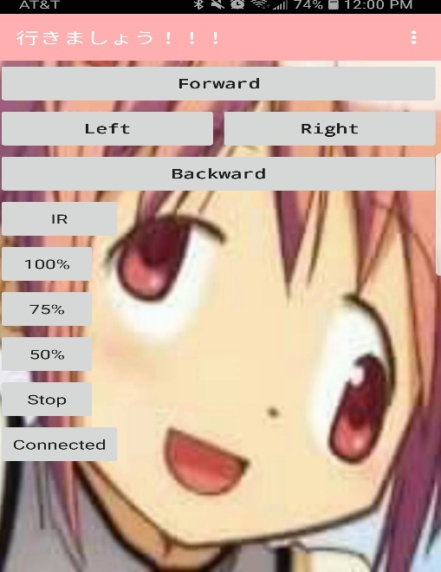

# Hardware Design:

There are two parts in this project; the car part and IR receiver part. The car’s major components are a microcontroller(TM4C123), a Bluetooth module(HC-05), a 5V regulator, an IR LED, an H-bridge module, four DC motors with four wheels, and a pack of four 3.7v lithium batteries shown in Figure 2, Figure 3, Figure 4. On the other side, the IR receiver consists of an IR receiver module, a MCU(TM4C123), and an LCD display(ST7735R) as shown in Figure 5.

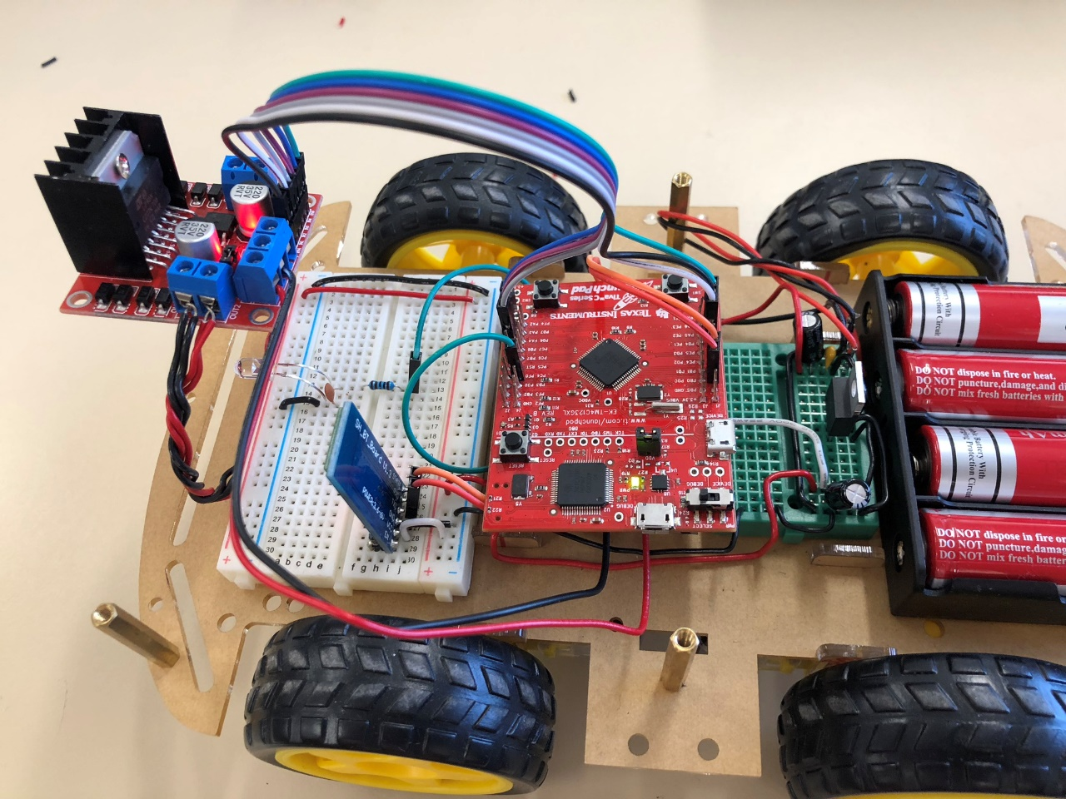

Figure 2: BT car overall connections

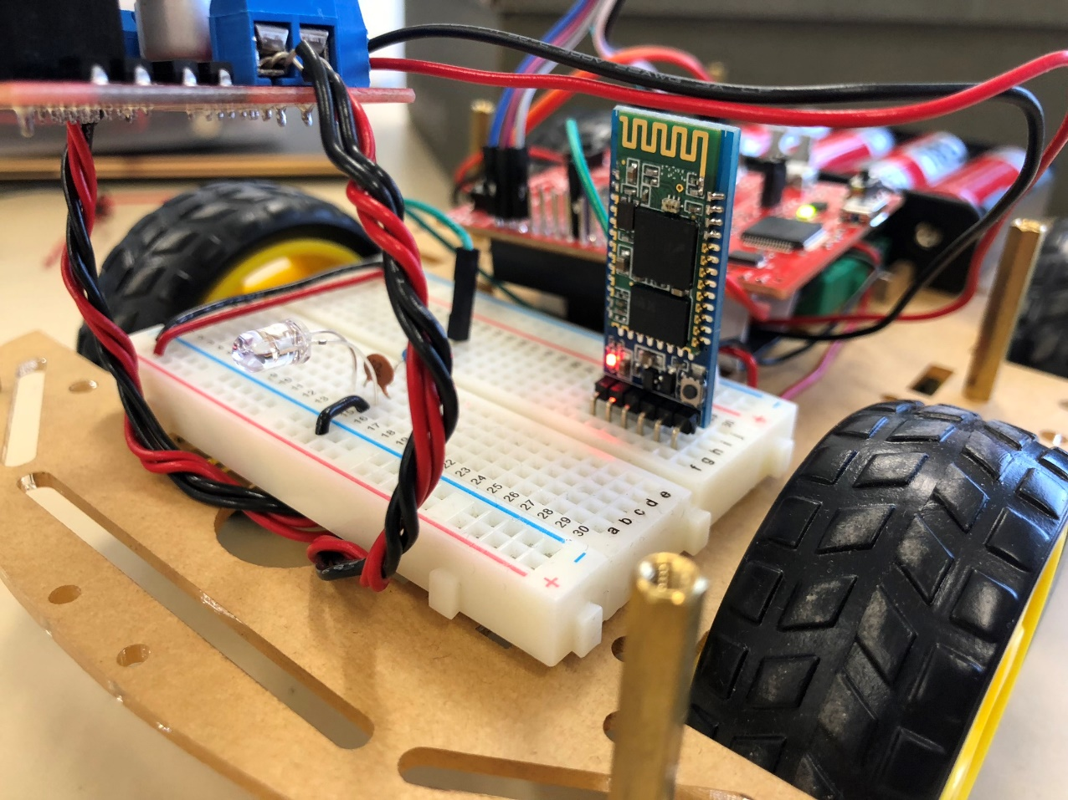

Figure 3: BT car's IR LED, BT module, and H-bridge module

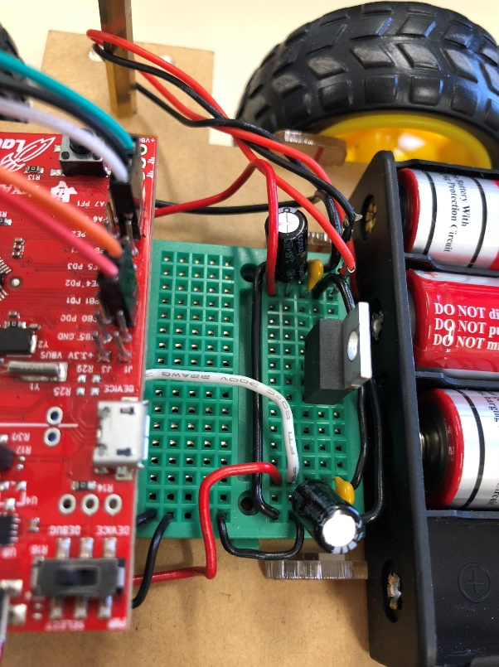

Figure 4: BT car's MCU, 5V regulator, and battery pack

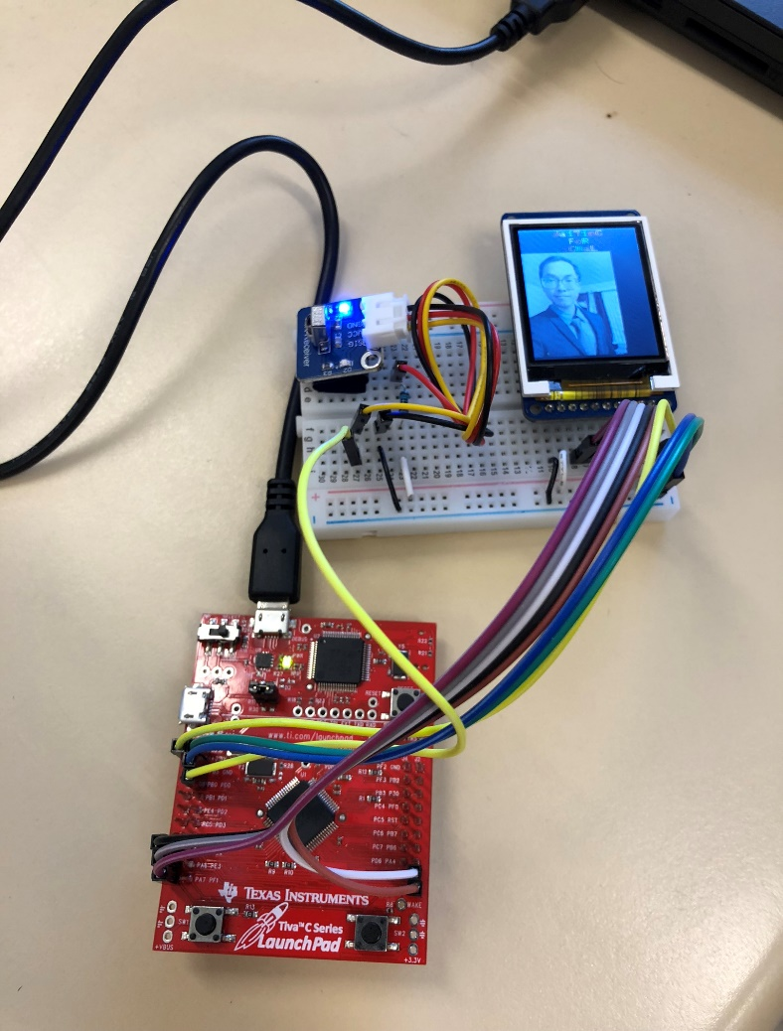

Figure 5: IR Receiver with MCU and LCD

## Top Level Schematic:

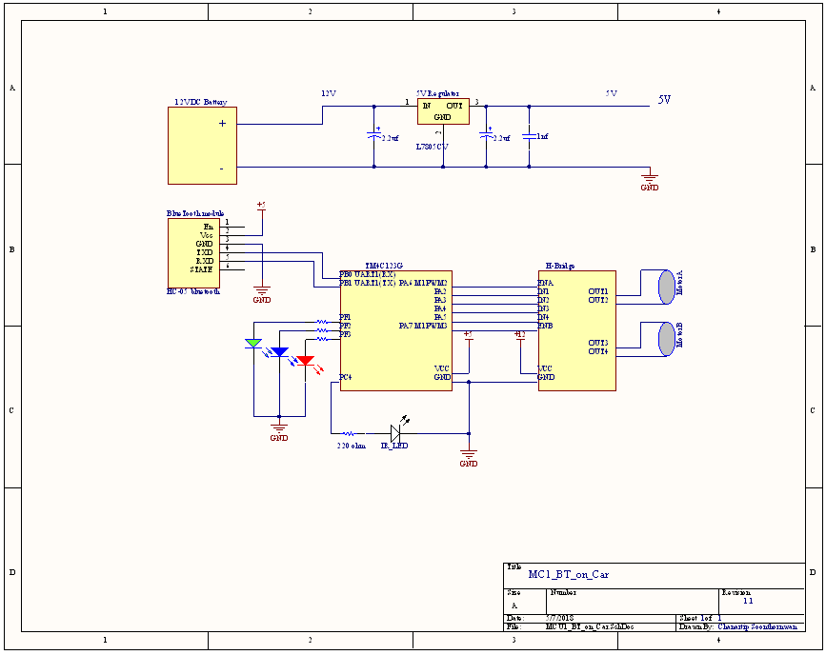

Figure 6: BT Car Schematic

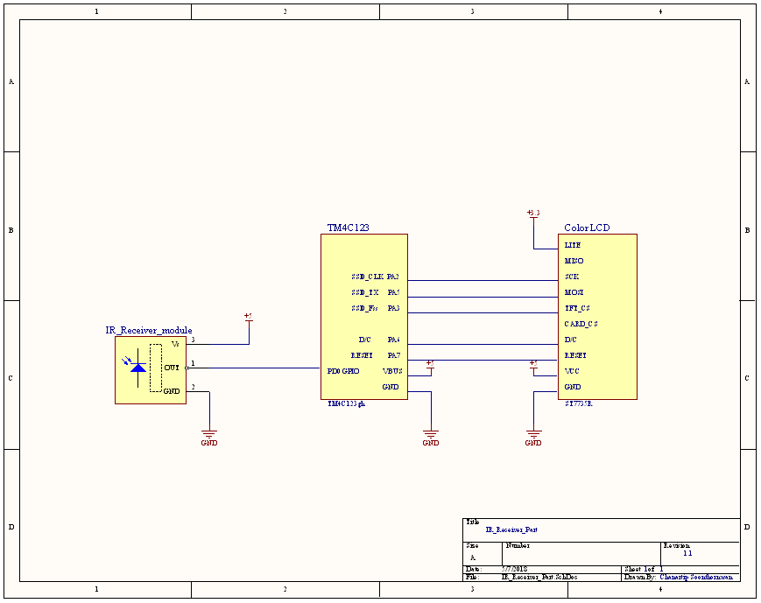

Figure 7: IR Receiver part Schematic

## List of Major Hardware Components:

2 TM4C123 Lauchpad Microcontrollers

1 HC-05 Bluetooth Module

1 L7805 5V regulator

4 DC motors with wheels

1 IR LED 940nm

1 IR Receiver module

1 ST7735R LCD

# Software Design:

As mention above, there are two parts for this project; one is the Bluetooth controlled car, and another is the IR receiver with LCD. The car itself consists three major designs, Bluetooth, DC motor control, and IR transmission.

Bluetooth control is basically transmitting and receiving data between a master (a smartphone) and a slave (the Bluetooth module HC-05 on TM4C123). Firstly, the slave is configured via consistently sending AT commands to define the slave as Name: CSSP, 57600 Baud Rate, 8-bit data, 1 stop, odd parity bit checking, and set the HC-05 in Slave Mode as shown the confirmation of the Bluetooth Configuration below. The slave will receive a character long command from its master and the program will decode the function of the command. For example, if the slave got ‘W’, the program would assign the current PWM duty to the DC motors with the set of the wheels direction of moving forward, or if the slave got ‘I’, the program would generate two frames of modulated IR signal through the IR LED.

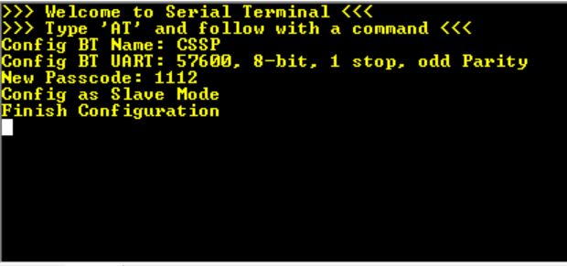

Figure 8: HC-05 configuration display on Serial Terminal.

DC-motor Control takes an action when the Bluetooth gets command for directions or speeds control. If the Bluetooth get W,A,S,D, or Q, DC motors will be assigned with current speed with a specific set of the direction of each command (as mention in Operation:). If the Bluetooth gets 1,2, or 3, the DC motors will be assigned a new PWM duty.

IR Transmission is to transmit IR signal by utilizing the Systick Interrupt to generate 40KHz modulated output through an IR LED. Once the Bluetooth gets ‘I’, it trigs the System for not continuously receiving any incoming command until the IR transmission is complete by setting a flag called IR_busy. While IR_busy is set, there is an IR counter to keep tracking in time when the modulated signal should be the Start bit, Logic 1, or Logic 0 (shown in Figure 9), while toggling the signal in its high time (shown in Figure 10).Once the IR transmission finishes, the program release IR_busy, so the system could receive new command.

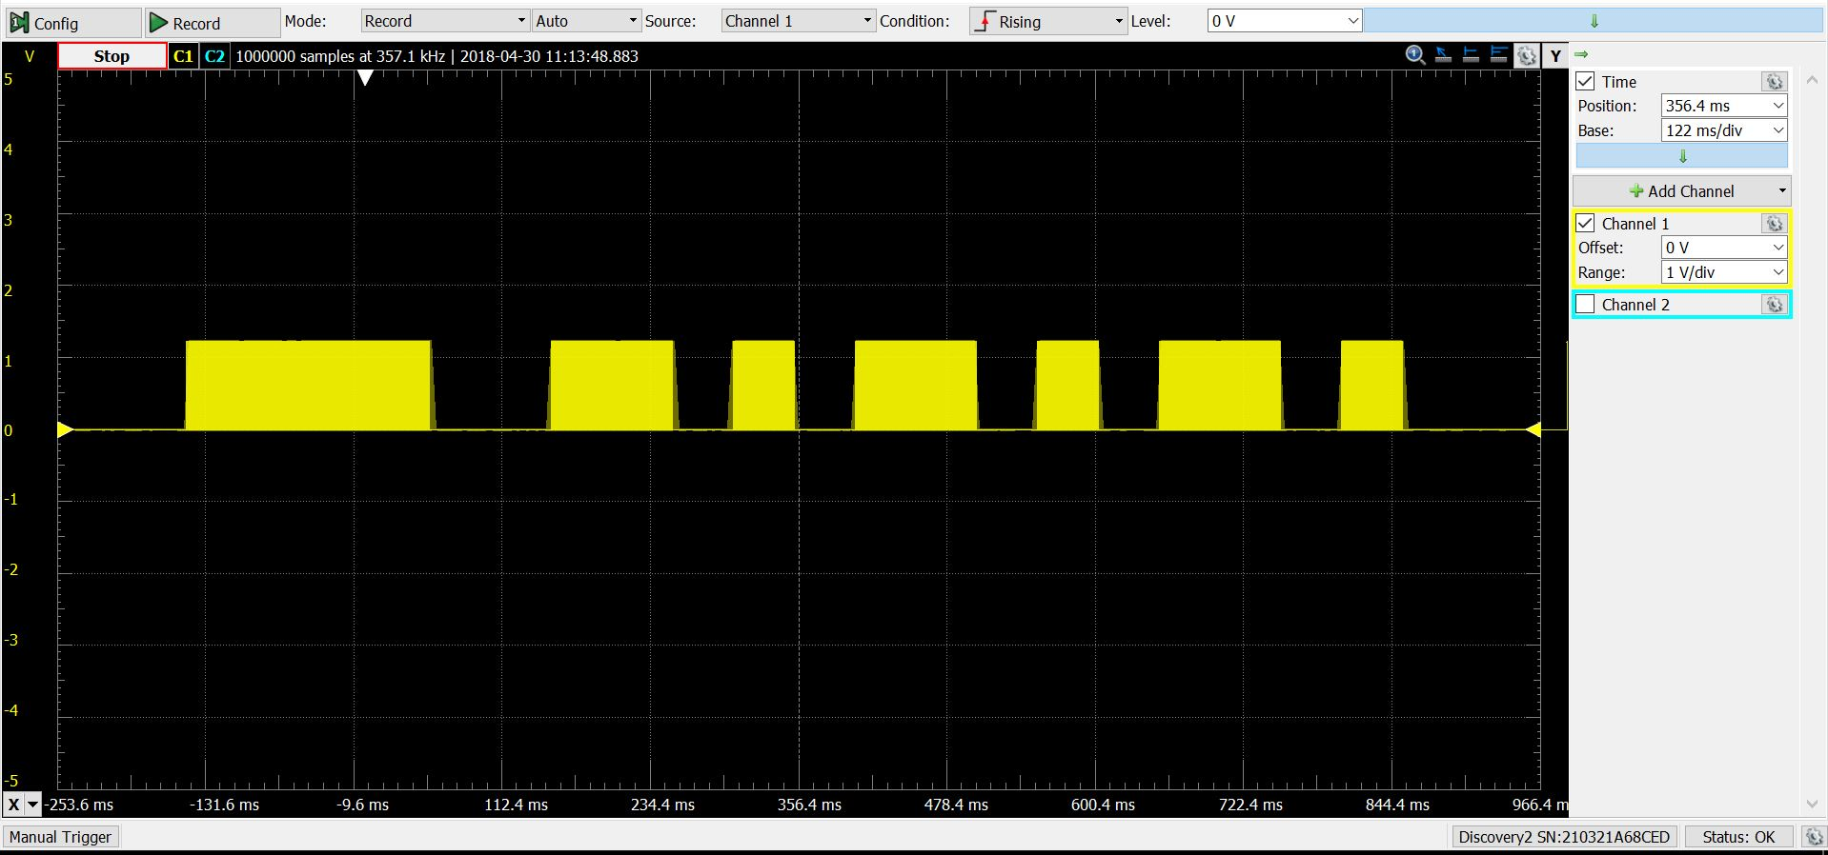

Figure 9: Modulated signal

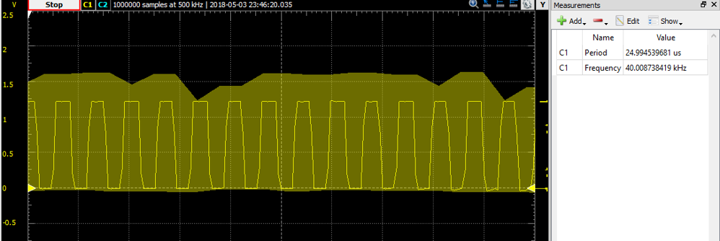

Figure 10: IR signal in High Time

On the other side, IR receiver with LCD utilize Systick Interrupt to consistently checking the input from IR-receiver module if there is a falling edge input occur stating that it probably is the start bit. Then, the interrupt sets a flag called Got_IR, reset IR timer, and number of the signal sample, therefore, the interrupt could only sample the input signals if they are valid in each stage’s period. If the inputs are not valid in the period, an error counter is incremented for later calculation. When the IR timer is reached 420 ticks(10.5ms) the interrupt would release the Got_IR and calculate the Error percentage. If the Error percentage is higher than 10 percent, the input is invalid, and the LCD will display the “Waiting for Signal”. Otherwise, the LCD will display “Got Signal” to confirm that the transmission is complete.

To find the periods of the signal, we create a code to check if the receiver gets start bit, and then displays the IR periods on each time the inputs do falling edge or rising edge (as shown in Figure 11) and utilizes the period to check error of the actual demodulated signal since both the code periods and actual periods should be similar.

|  |  |
| --- | --- |
| Figure 11: Displaying periods of input level changes | Figure 12: Applied tested period in Systick Interrupt |

In order to confirm the signal visually, we use Analog Discovery2 to scope the output of modulated IR signal from the IR LED on the car and demodulated IR signal from the IR Receiver module, and the display both signals on top of each other with slightly shifted as the signal takes time traveling in the air (shown in Figure 13).

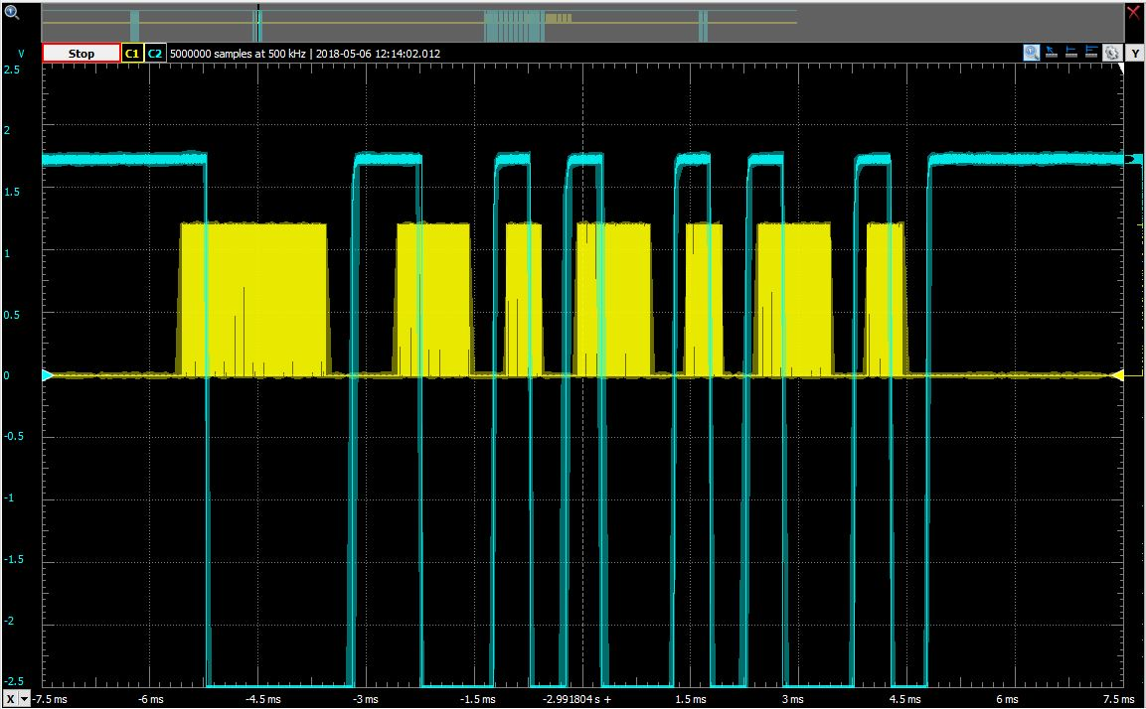

Figure 13: Modulated and Demodulated IR signal in Yellow Cyan

## Programing flow:

Figure 14: BT_on_car programming flow

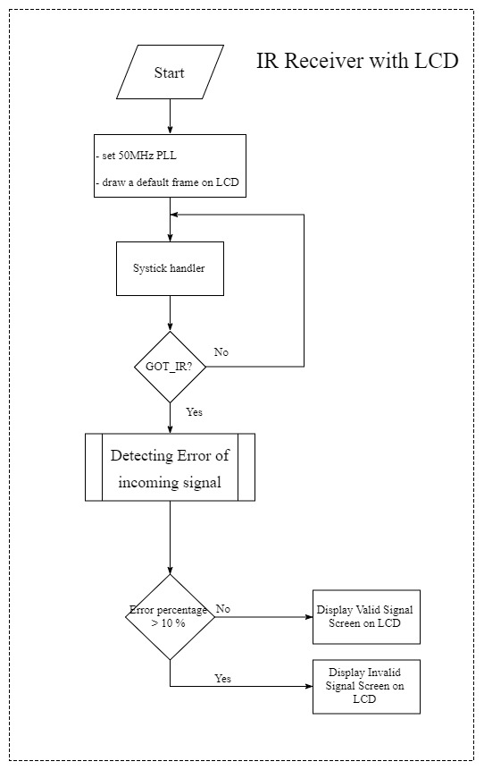Figure 15: IR_Receiver_with_LCD programming flow

# Conclusion:

The most challenging part of this project was to transmit and receive IR signal correctly. To transmit the signal, generating 40KHz modulated signal is troublesome. Since the signal is 40KHz, we utilize 80KHz Systick Interrupt to toggle the IR LED output on each interrupting called, so a period of the signal is at 40KHz. In the meantime, while toggling the signal, we keep tracking if the signal time is in which state of the IR signal. For instance, the IR signal should toggle in Start bit high time and should stay low in low time. The problem was during the transmission the system should not have a busy wait or any approach that causes the IR signal time skew. If so the signal would not be sent properly.

On receiving side, firstly, we need to know the periods of each state on the signal and make them as references for the incoming IR signal (as shown in Figure 11), so we hardcoded the period and check errors as we only have one IR command.

Another challenge is to control the car via the Bluetooth application on a smartphone. We firstly tried to press and hold a command button and then let go of the button. We found that the car was consistently moving forward as we assigned ‘W’, which made a difference from any Remote-Control car. Fortunately, the Bluetooth API allows us to setup an event when releasing a button after holding it, so we send ‘Q’ to stop the car as we release our finger off the button, which provides the better experience controlling the car. Furthermore, it could have been better if our car could actually turn left in the sense that a user holding ‘W’ and ‘A’ at the same time.

Lastly, the LCD refresh rate could have been smoother as it refreshes a new frame on the screen even though 140Hz has been used as the refresh rate for the screen, but we believe that it is the limit of the hardware itself.

Intentionally left blank